
INSTRUCTIONS: Geneva School District
- Access the Login Screen
Enter www.gcntraining.com into your browser’s address bar.  When the website loads, click LOGIN TO VIEW TRAINING | 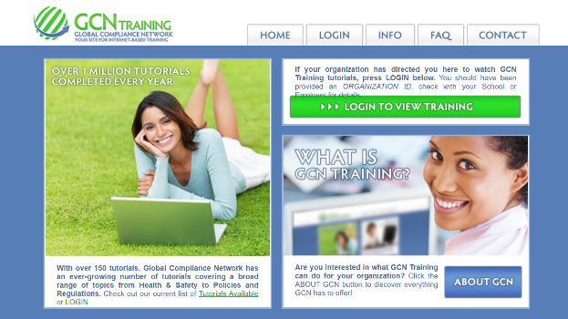
- New or Existing User?
If you see this step, click “Version 5 User Login”
- Enter your Organization ID
The Organization ID is a code unique to each organization.  Geneva CUSD 304’s Organization ID is 48195g. | 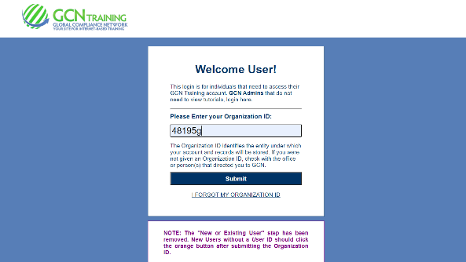
- The User ID
If you do NOT have a User ID click  and follow the prompts to create one.  If no account is found, check with your HR Department or Supervisor to see if there is an issue with your account/name – it may be a difference of “Smith-Jones” vs “Smith Jones” or “VanHoff” vs “Van Hoff”. | If you have created a User ID already, enter your User ID and click Submit  If you’ve forgotten your User ID, click “I forgot my User ID” and follow the prompts.
- The Tutorial Listing Page
On the Tutorial Listing page you’ll see a list of tutorials your organization has either required or has made available to you – if the list does not specifically state “Required”, it’s possible that not all on the list are required (your organization may provide a list for you in this case).

Take notice of any articles in the News & Information area to the right of this page.
- Viewing Tutorials
To view a tutorial, click START to the left of any title in the list. Your progress is saved after each slide completes, so you may complete a tutorial in several sessions.

If you have trouble viewing a tutorial or slide, use the orange buttons below the tutorial viewer.

